Syntax-1 always generates sequence of integers in increment order. It always generates +ve sequence of integers

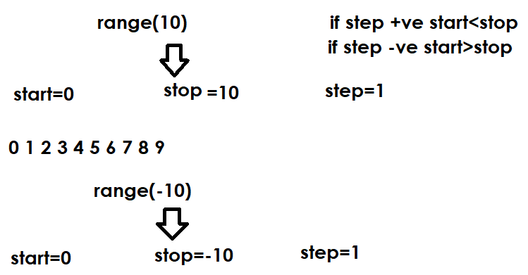

Range data type given start and stop values based on step value
If step is +ve , start<stop
If step is –ve, start>stop

Syntax-2: range(start,stop,[step=1])

Example:
for value in range(1,11): # start=1,stop=11,step=1
print(value,end=' ')

print()
for value in range(-10,0): # start=-10,stop=0,step=1
print(value,end=' ')

print()
for value in range(10,0,-1): # start=10,stop=0,step=-1
print(value,end=' ')

print()
for value in range(-1,-11,-1): # start=-1,stop=-11,step=-1
print(value,end=' ')

# generate 2 4 6 8 10 12 14 16 18 20

print()
for value in range(2,21,2):
print(value,end=' ')

# generate 1 3 5 7 9 11 13 15 17 19
print()
for value in range(1,20,2):
print(value,end=' ')
#gnerate -5 -4 -3 -2 -1 0 1 2 3 4 5
print()
for value in range(-5,6,1):
print(value,end=' ')
#generate 5 4 3 2 1 0 -1 -2 -3 -4 -5
print()
for value in range(5,-6,-1):
print(value,end=' ')
#generate 1 4 9 16 25 36 49 64 81 100
print()
for value in range(1,11,1): # 1 2 3 4 5 6 7 8 9 10
print(value**2,end=' ')
#generate A B C D E F G .... Z
print()
for value in range(65,91,1):
print(chr(value),end=' ')
#generate a b c d e f g .... z
print()
for value in range(97,123,1):
print(chr(value),end=' ')

Output
1 2 3 4 5 6 7 8 9 10
-10 -9 -8 -7 -6 -5 -4 -3 -2 -1
10 9 8 7 6 5 4 3 2 1
-1 -2 -3 -4 -5 -6 -7 -8 -9 -10
2 4 6 8 10 12 14 16 18 20
1 3 5 7 9 11 13 15 17 19
-5 -4 -3 -2 -1 0 1 2 3 4 5
5 4 3 2 1 0 -1 -2 -3 -4 -5
1 4 9 16 25 36 49 64 81 100
A B C D E F G H I J K L M N O P Q R S T U V W X Y Z
a b c d e f g h i j k l m n o p q r s t u v w x y z

Example:
# Write a program to generate math table
# for given input number

# 5x1=5
# 5x2=10
# 5x3=15
#...
# 5x10=50

num=int(input("Enter any number "))
for i in range(1,11): # 1 2 3 4 5 6 7 8 9 10
p=num*i
print(f'{num}x{i}={p}')

Output
Enter any number 9
9x1=9
9x2=18
9x3=27
9x4=36
9x5=45
9x6=54
9x7=63
9x8=72
9x9=81
9x10=90
Example:
# Write a program to find input number is
# prime number or not using for loop

num=int(input("Enter any number "))
c=0
for i in range(1,num+1):
if num%i==0:
c=c+1

if c==2:
print(f'{num} is prime')
else:
print(f'{num} is not prime')

Output
Enter any number 5
5 is prime

Enter any number 4
4 is not prime

Example:
# Write a program to find factorial of
# input number

num=int(input("enter any number "))

fact=1
for i in range(1,num+1):
fact=fact*i

print(f'factorial of {num} is {fact}')

Output
enter any number 4
factorial of 4 is 24

enter any number 7
factorial of 7 is 5040

What is difference between while and for loop?
While | For
While loop is used to repeat a block of statements until given condition | For loop is used to repeat a block of statements number of times

Branching statements
Branching statements are used to control the execution of looping control statements (while and for)
Python supports 2 branching statements
- break
- continue

Note: break,continue are called keywords in python

break
“break” is keyword which represents branching statement
This statement is used inside looping control statements like while and for loop
This statement is used to terminate execution of for loop or while loop in between or unconditionally.

Example:
for x in range(1,6):
print("PYTHON")
break

i=1
while i<=5:
print("DJANGO")
i=i+1
break

Output
PYTHON
DJANGO

